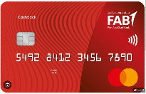 FAB Feature Prioritization

**Objective :** Primary Strategy is aimed at developing User experience by refining the backlog UserStories

**About**

FAB one of the largest bank in Gulf offers financial solutions, products and services through its Corporate and Investment Banking and Personal Banking franchises. Recently FAB has decided to come up with Low rate Credit card which will provide Balance /cash transfer facility to Consumers. FAB has identified there is an existing market where competitors like Mashreq, CBD are also launching same functionary Product. Fab decided to do come up with the following features which will benefit the customers on their daily savings.

**Feature Proposal**

|  |  |  |
| --- | --- | --- |
| **Code** | **Description** | **Benefit** |
| F1 | Low Rate Card | User acquisition , User Adoptation |
| F2 | Balance Transfer | Market capitalization and Penetration |
| F3 | Cash Back Feature | Extended engagement ,Brand recognition |
| F4 | Loan on Prepaid card | Brand Advocacy |
| F5 | Rewards to Gold Members | Data driven personalization |
| F6 | Membership Fee | Monetization |
| F7 | 0 % interest on Loan Repayment | Enhanced User Satisfaction |

**Users :**

|  |  |
| --- | --- |
| **User Id** | **User Name** |
| user1@example.com | User 1 |
| user2@example.com | User 2 |
| user3@example.com | User 3 |
| user4@example.com | User 4 |
| user5@example.com | User 5 |
| user6@example.com | User 6 |
| user7@example.com | User 7 |
| user8@example.com | User 8 |
| user9@example.com | User 9 |
| user10@example.com | User 10 |
| user11@example.com | User 11 |
| user12@example.com | User 12 |
| user13@example.com | User 13 |
| user14@example.com | User 14 |
| user15@example.com | User 15 |

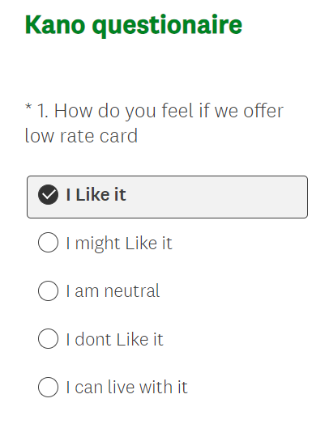 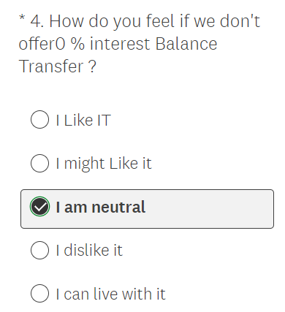 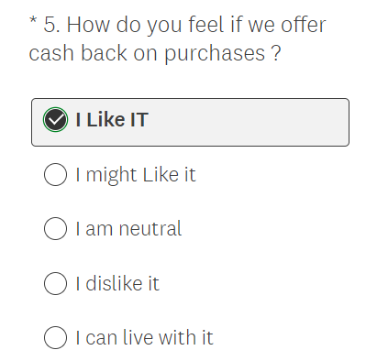

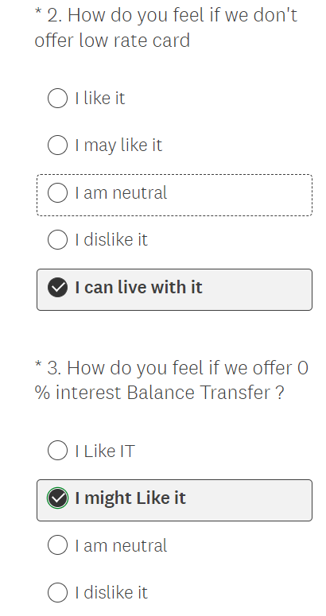 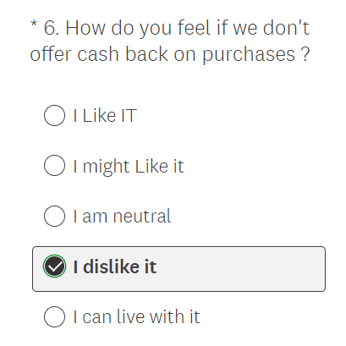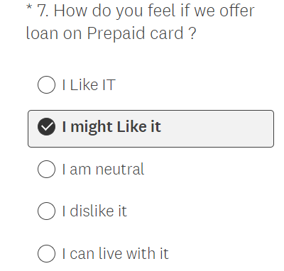

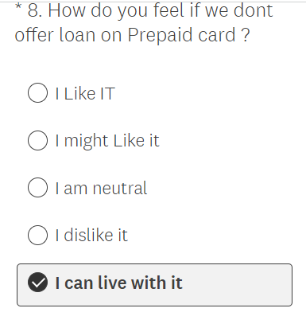 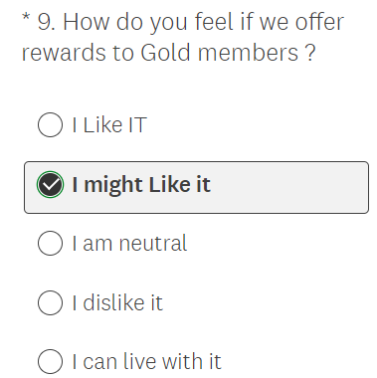 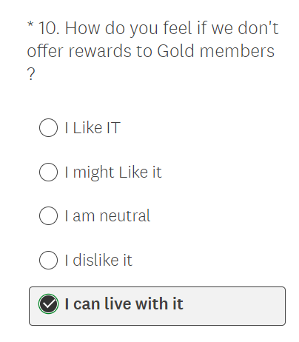

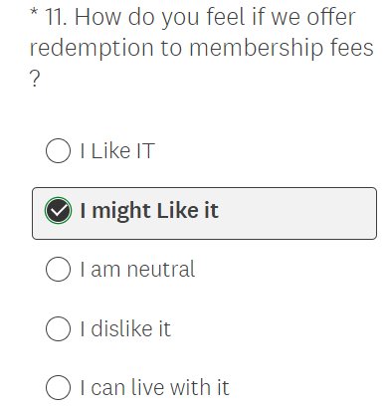 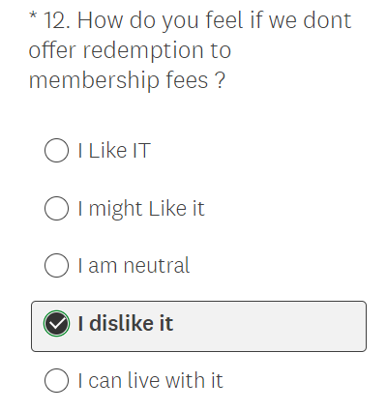 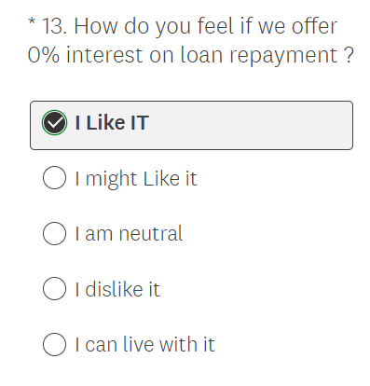

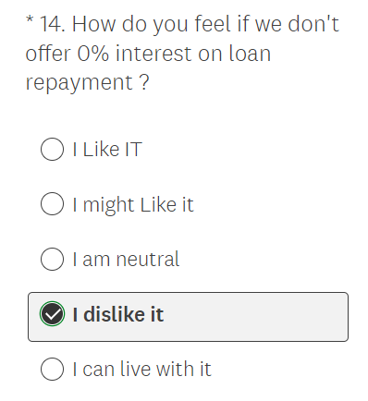

STEP -2 EVALUATION TABLE



**Kano Evaluation Table**

|  |  |  |  |  |  |  |  |  |
| --- | --- | --- | --- | --- | --- | --- | --- | --- |
| Customer requirements | *Delight* | *Performance* | *Mandatory* | *InDifferent* | *Reverse* | *Questionable* | Total | kano category |
| F1 | 2 | 5 | 2 | **2** | 2 | 1 | 15 | Performance |
| F2 | 2 | **4** | 3 | 2 | 2 | 2 | 15 | Performance |
| F3 | 3 | 3 | **4** | 2 | 2 | 1 | 15 | Mandatory |
| F4 | 3 | 2 | 3 | 3 | **4** | 0 | 15 | Reverse |
| F5 | 2 | 3 | **4** | 2 | 3 | 1 | 15 | Mandatory |
| F6 | 3 | 3 | 2 | **4** | 2 | 1 | 15 | InDifferent |
| F7 | **4** | 3 | 3 | 2 | 2 | 1 | 15 | Delight |